AlphaMD Monitoring Report
Please find attached Routine Monitoring report of AWS AlphaMD Account based on 6th January 2026
Monitoring Summary (7th January)
Cost Consumption:
- Current Cost: $54.50 from last 24 hours.
- Total cost from 1st January to 7th January: $510.28 (Tax Included).
EC2 Instances:
- Total: 8 EC2 instances in Mumbai (7 instances are in running state & 1 instance is in stopped state) and 7 EC2 instances in London (7 instances are in running state & 0 instances are in stopped state)
- Instance Table (Mumbai Region):
Instance name | Instance ID | State | CPU Utilization  Min | CPU Utilization  Max | CPU Utilization  avg | Network  In  (MB/s) | NetworkOut (MB/s)
Alpha-Linux-Bastion | i-0e03269b2b8e7d785 | Running | 0.2% | 0.29% | 0.25% | 2.05 MB | 14.9 kB
UAT-APP-SERVER-Deployment-box--Do Not Terminate | i-08cf777f4ed2306d9 | Running | 0.55% | 0.76% | 0.66% | 99.2 kB | 63.1 kB
UAT-Web-server-Deployment-Box---Do not terminate | i-0574117d257a74ba5 | Running | 0.29% | 0.29% | 0.29% | 19.2 kB | 34.3 kB
AMDHA Staging Node 1 | i-0405f1bc4395c94d8 | Running | 0.29% | 0.29% | 0.29% | 1.73 MB | 455 kB
UAT-Wordpress-LiberatePro | i-0edd954822b8da6eb | Running | 0% | 0% | 0% | 0 kB | 0 kB
AMDHA Prod | i-09a65af23bed7a3ed | Running | 6.17% | 6.88% | 6.53% | 1.8 MB | 1.16 MB
Fusion Auth AMDHA Prod | i-01d69faf9627baad7 | Running | 3.99% | 4.13% | 4.06% | 1.02 MB | 131 kB
AMDHA Staging Node 2 | i-066f1c3d855d597e8 | Running | 3.04% | 3.08% | 3.06% | 1.42 MB | 190 kB

- Instance Table (London Region):
Instance name | Instance ID | State | CPU Utilization  Min | CPU Utilization  Max | CPU Utilization | Network  In (MB/s) | NetworkOut (MB/s)
Prod-Alpha-Linux-Bastion | i-040fb1b7cd039bfb5 | Running | 0.23% | 0.23% | 0.23% | 4.05 kB | 3.21 kB
PROD-Wordpress-LiberatePro | i-003d30e064c1f0115 | Running | 1% | 1% | 1% | 1.15 MB | 151 kB
Prod-Web-server-Deployment-Box---Do not Terminate | i-0194e7da8f44a5dbf | Running | 0.2% | 0.2% | 0.2% | 9.6 kB | 30.4 kB
Prod-APP-server-Deployment-Box---Do not Terminate | i-0805cadc57f81c1db | Running | 0.58% | 0.58% | 0.58% | 54.9 kB | 11.5 kB
Prod-Web-server-ASG-LT | i-085371e18d979dfca | Running | 0.13% | 0.13% | 0.13% | 7.34 kB | 34.4 kB
PROD-APP-SERVER-ASG |  | Running
PROD-APP-SERVER-ASG |  | Running

- CPU Utilization:
  - High utilization:
- Mumbai Region Instance:
No high utilization in the Mumbai region
- London Region Instance:
No high utilization in the London region
- Overall low utilization for other instances.
- No unusual patterns detected.

EBS (Elastic Block Store):
- Total: 8 Volumes in Mumbai and 6 Volumes in London
- EBS Volume Latency Monitoring Table (Mumbai Region):
Volume ID | Read Latency (ms) | Write Latency (ms) | Notes (Analysis & Recommendations)
vol-067ad35a6a05e3f6e | 0 | 1.264 | Slightly higher write latency.
vol-06c8f95f6501aee0c | 0.003 | 0.874 | Latency within the normal range
vol-0e50c5b51ad753b6f | None | None | No recent activity recorded.
vol-09a05908e1b547899 | 0.006 | 0.867 | Latency within the normal range
vol-011c43bfc0fe19c59 | 0.046 | 0.541 | Latency within the normal range
vol-040d3f46c97620763 | 0 | 1.19 | Slightly higher write latency.
vol-05745747ee019d7bb | 0.005 | 0.862 | Latency within the normal range
vol-091883bfc48f48d09 | 0.104 | 0.893 | Latency within the normal range

- EBS Volume Latency Monitoring Table (London Region):
Volume ID | Read Latency (ms) | Write Latency (ms) | Notes (Analysis & Recommendations)
vol-00abb2c983be19913 | 0.024 | 0.859 | Latency within the normal range
vol-0fc0d2d4b62164530 | 0.0054 | 0.866 | Latency within the normal range
vol-0586cc5ca8b597ec6 | 0.007 | 0.864 | Latency within the normal range
vol-02d622b33637d9f8b | 0.004 | 0.843 | Latency within the normal range
vol-0175b893ff175c1e8 | 0 | 1.149 | Slightly higher write latency.
vol-03aad4af9e25d8820 | 0.012 | 0.865 | Latency within the normal range
Threshold:
- Normal: ≤ 5 ms
- Warning: Between 5 ms and 10 ms
- Critical: > 10 ms
Action: If latency is high, check if the volume is over-utilized. Consider provisioning more IOPS or using a lower-latency volume type (like io1/io2).

RDS Instances:
- Mumbai Region RDS Instance CPU Utilization:
RDS Name | Status | Role | CPU Utilization
alpha-dev-db | Available | Instance | 2.89%
alpha-uat-db | Available | Instance | 3.14%
amdha-fa-dev | Available | Instance | 5.38%
liberate-lite-local-dev | Available | Instance | 3.21%
lp-wordpress-dev-db | Available | Instance | 3.70%
prod-dev-alphamd-db-mumbai | Available | Instance | 3.18%
uat-lite-uk-db | Available | Instance | 3.30%

- London Region RDS Instance CPU Utilization:
RDS Name | Status | Role | CPU Utilization
lp-prod-wordpress-db | Available | Instance | 3.57%
prod-alphamd-db | Available | Instance | 3.44%

- CPU Utilization:
  - No High utilization (Mumbai Region)
- CPU Utilization:
  - No High utilization (London Region)

- Overall low utilization for RDS.
- No unusual patterns detected.
S3 and Auto Scaling Groups (ASG):
- ASGs:
  - Total 6 provisioned in both region:
    - Mumbai Region: 4 ASG
    - London Region: 2 ASG
- S3 Buckets:
  - Total 25 Buckets in both region:
    - Mumbai Region: 23 Buckets
    - London Region: 6 Buckets
    - California Region: 1 Bucket
Certification Status:
- Mumbai:
  - Total 5 Certificates in Mumbai. 4 issued, 1 expired.
Certificate ID | Domain | Status | Expiry Date | Expires in
c48eb1f9-e485-407a-9cff-6a6bb84a90d2 | *.arha.health | Issued | March 17, 2026, 05:29:59 (UTC+05:30) | -
2e33e156-9f5c-4503-a577-9d3bbf34e639 | *.amdha.health | Issued | July 08, 2026, 05:29:59 (UTC+05:30) | -
066da290-0c68-4c0f-9694-094401ad43cb | *.liberateprohealth.com | Issued | December 12, 2025, 11:39:47 (UTC+05:30) | 38 days
593fda20-48ed-4e96-ba81-4169451b3fe0 | *.liberateprohealth.com | Issued | December 12, 2025, 11:39:47 (UTC+05:30) | 38 days
b346e154-799f-493c-83ef-d5d4d18734d8 | *.liberateworks.com | Expired | April 12, 2022, 05:29:59 (UTC+05:30)

- London:
  - Total 2 Certificates in London. 1 Issued, 1 Expired.
Certificate ID | Domain | Status | Expiry Date | Expire in
2a53f82a-b1ad-4435-8563-399cdc55b3f9 | *.liberateprohealth.com | Issued | December 12, 2025, 11:39:47 (UTC+05:30) | 38 days
3453583a-2e8d-486a-adeb-491cb1432088 | *.liberateworks.com | Expired | April 12, 2022, 05:29:59 (UTC+05:30)

Matrices Screenshot:
- CPU Utilization Mumbai region for EC2:
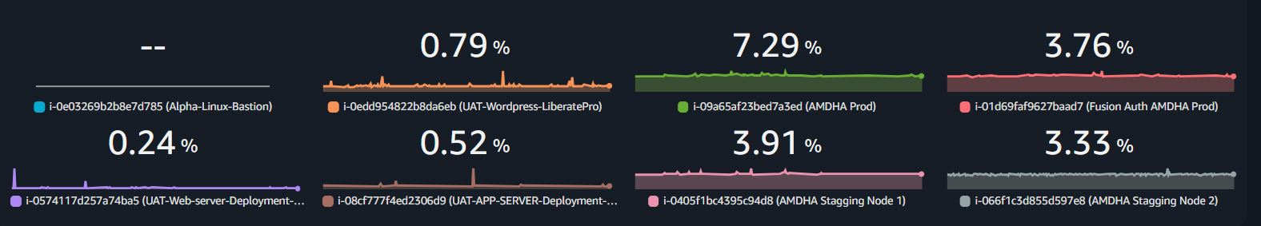
- Network in bytes Mumbai region for EC2:
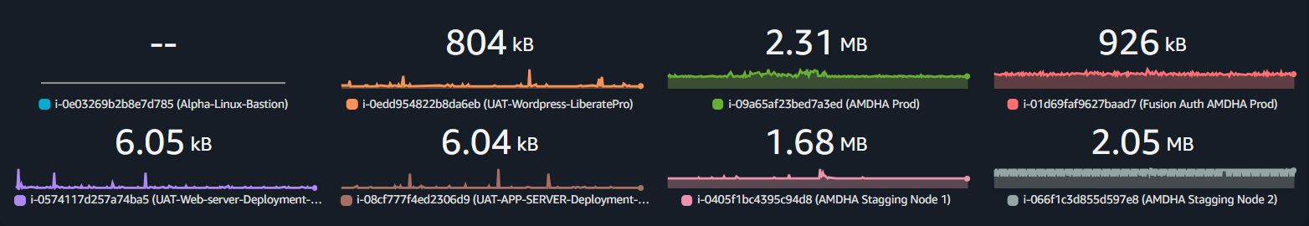
- Network out bytes Mumbai region for EC2:
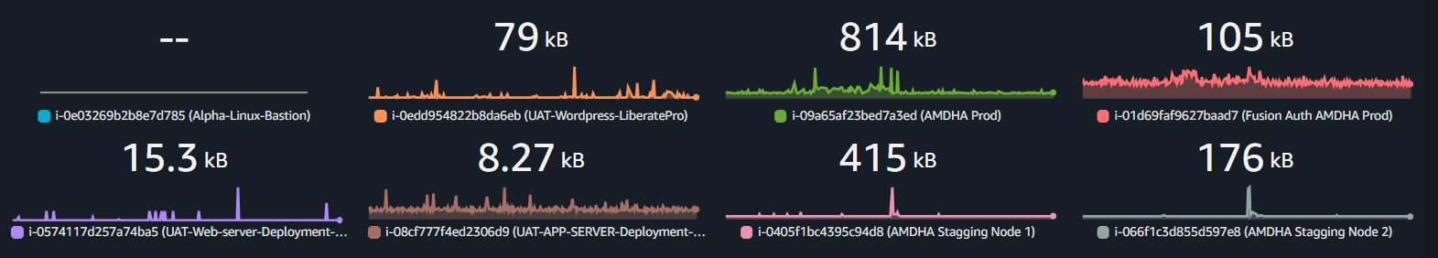
- Network packets in Mumbai region for EC2:
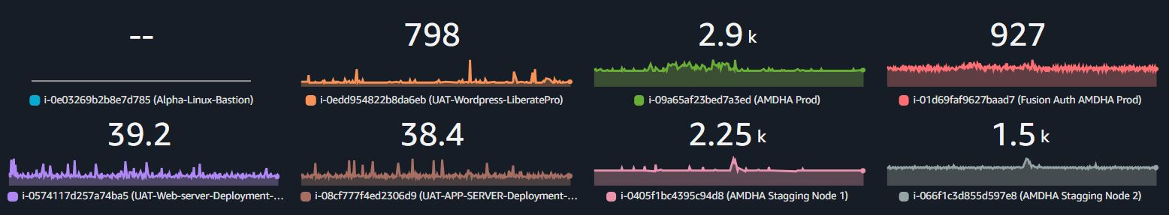
- Network packets out Mumbai region for EC2:
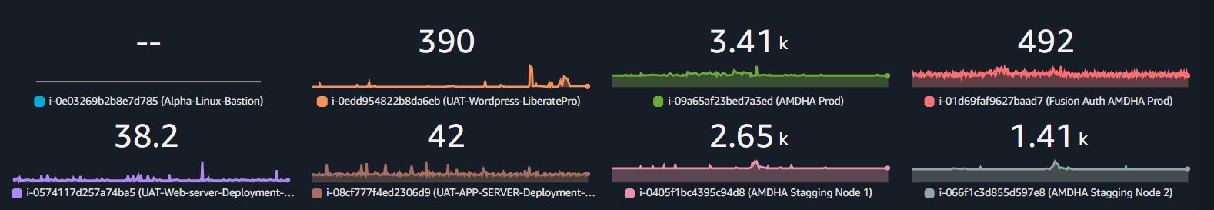
- Read/Write Latency Mumbai region for EBS:
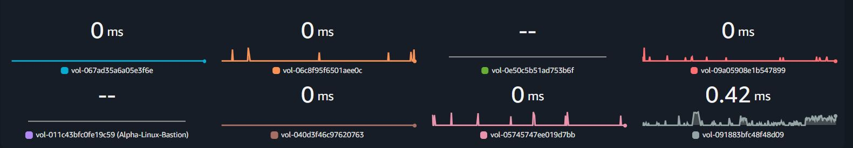
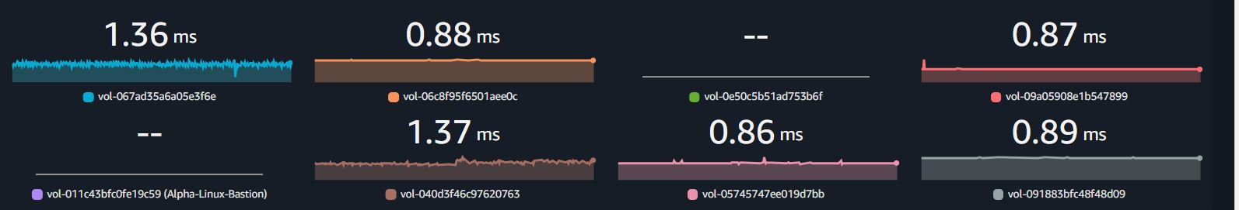
- VolumeQueueLength Mumbai region for EBS:
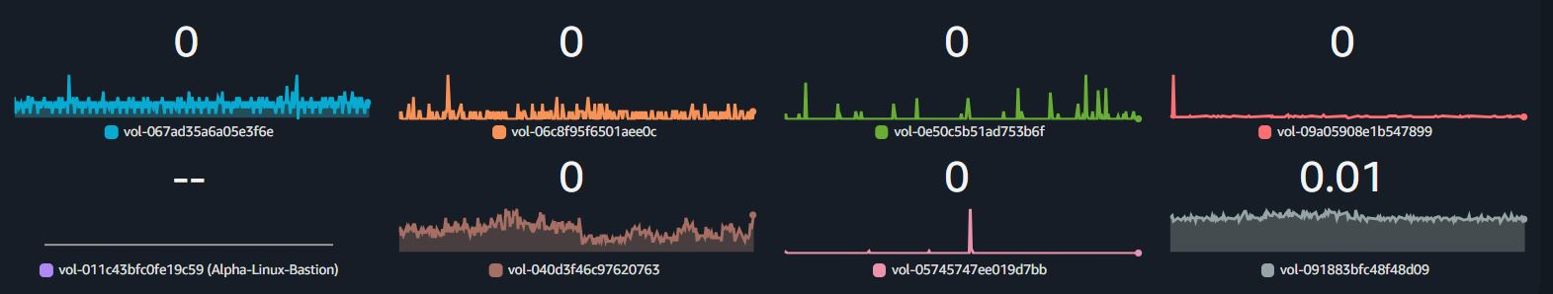
Threshold:
- Normal: ≤ 1 per volume
- Warning: Between 1 and 5 (indicates some congestion)
- Critical: > 5 (may cause performance degradation)
Action: If consistently high, consider increasing IOPS or changing volume type.
- BurstBalance (%) Mumbai region for EBS:
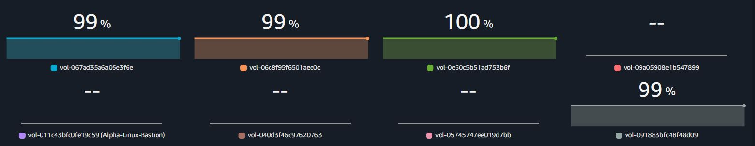
Threshold:
- Normal: > 80% (good burst credit balance)
- Warning: Between 20% and 80% (burst credits are being used frequently)
- Critical: < 20% (performance will drop significantly soon)
Action: Upgrade to gp3 (no burst limits) or provisioned IOPS (io1/io2) if sustained high performance is needed.
- Read/Write Throughput (KiB/s) Mumbai region for EBS:
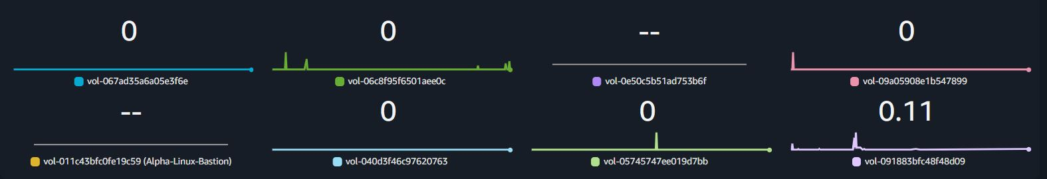
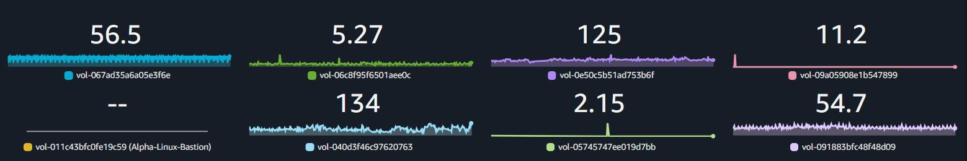
Threshold:
- Compare with EC2 instance bandwidth limits
- If reaching instance limits: May need a higher EC2 instance type
- If below expected throughput: Possible bottleneck in application or disk type
Action: If you need sustained higher throughput, consider gp3, io1, or io2.

- Read/Write latency London region EBS:
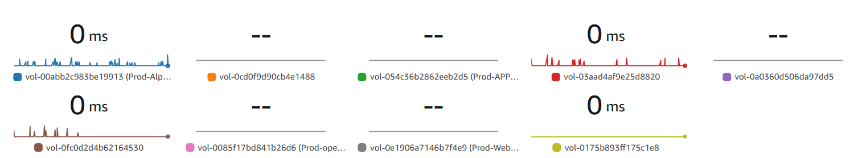
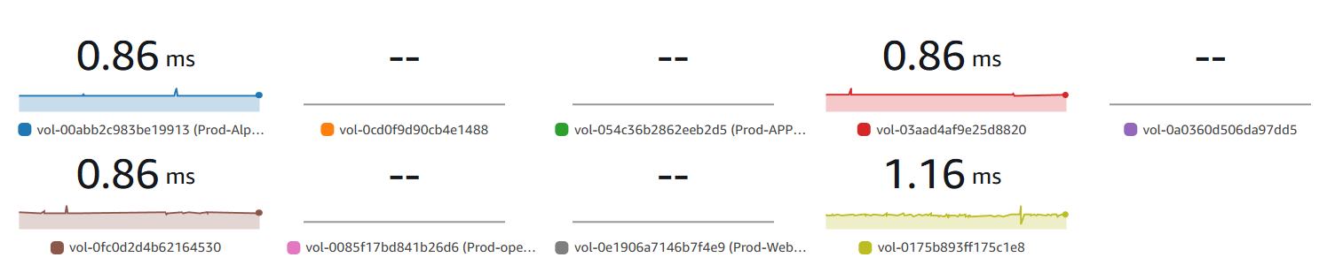
- VolumeQueueLength London region EBS:
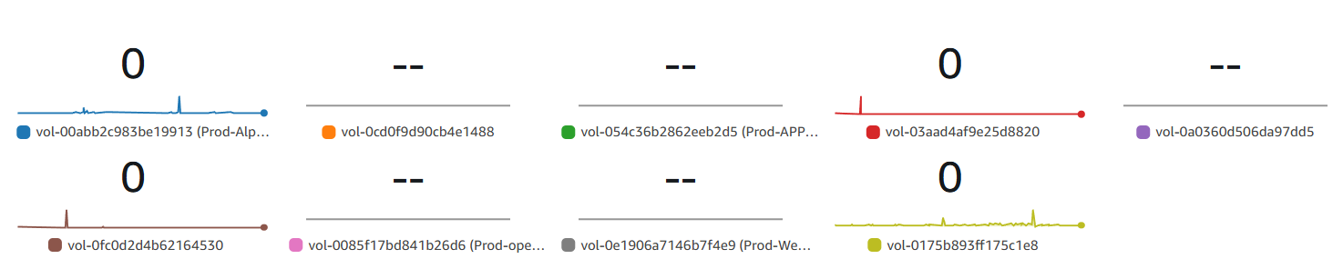
- BurstBalance (%) London region for EBS:
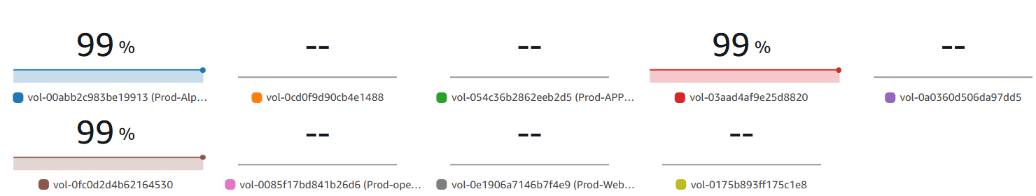
- Read/Write Throughput (KiB/s) London region for EBS:
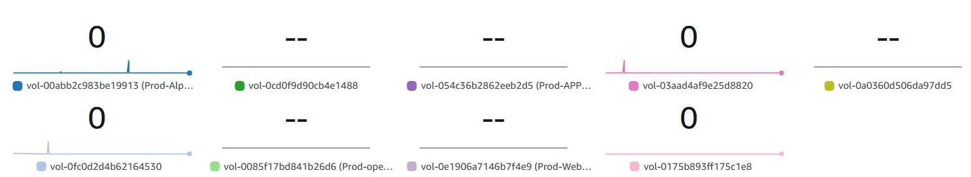
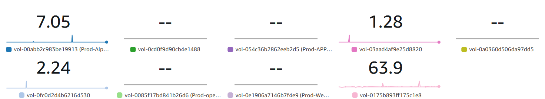
- CPU Utilization Mumbai region for RDS:
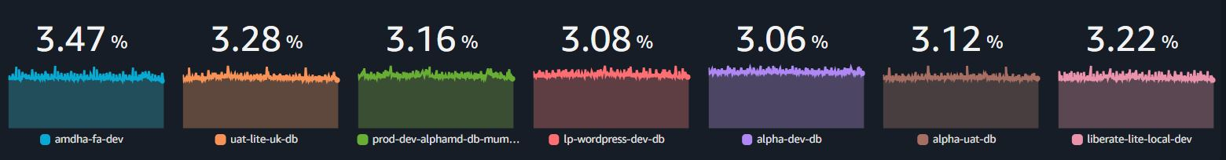
- CPU Utilization London region for EC2:
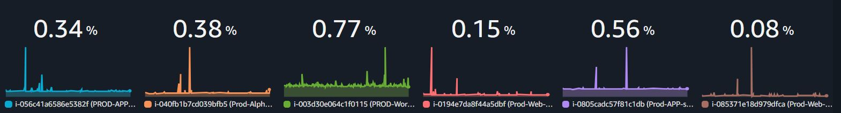
- Network in bytes London region for EC2:
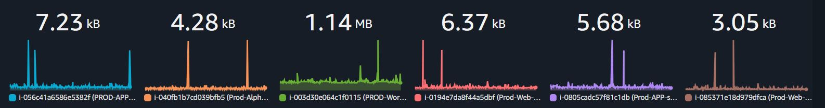
- Network out bytes London region for EC2:
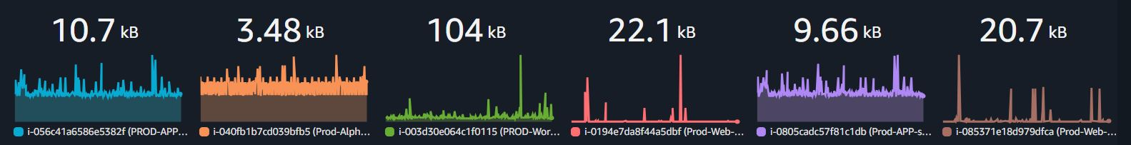
- Network packets in count London region for EC2:
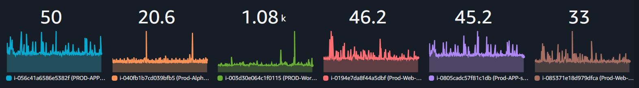
- Network packets out count London region for EC2:
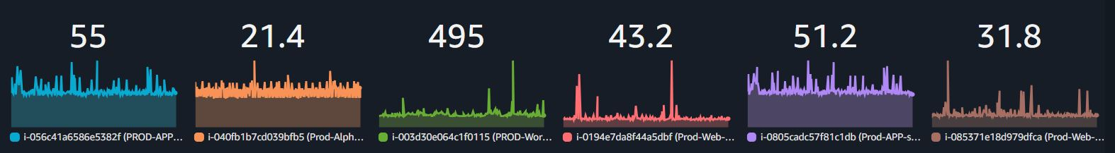
- CPU Utilization London region for RDS:
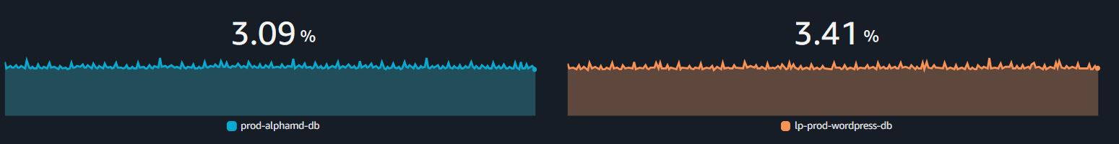
- Bucket size bytes for S3 (Mumbai Region):
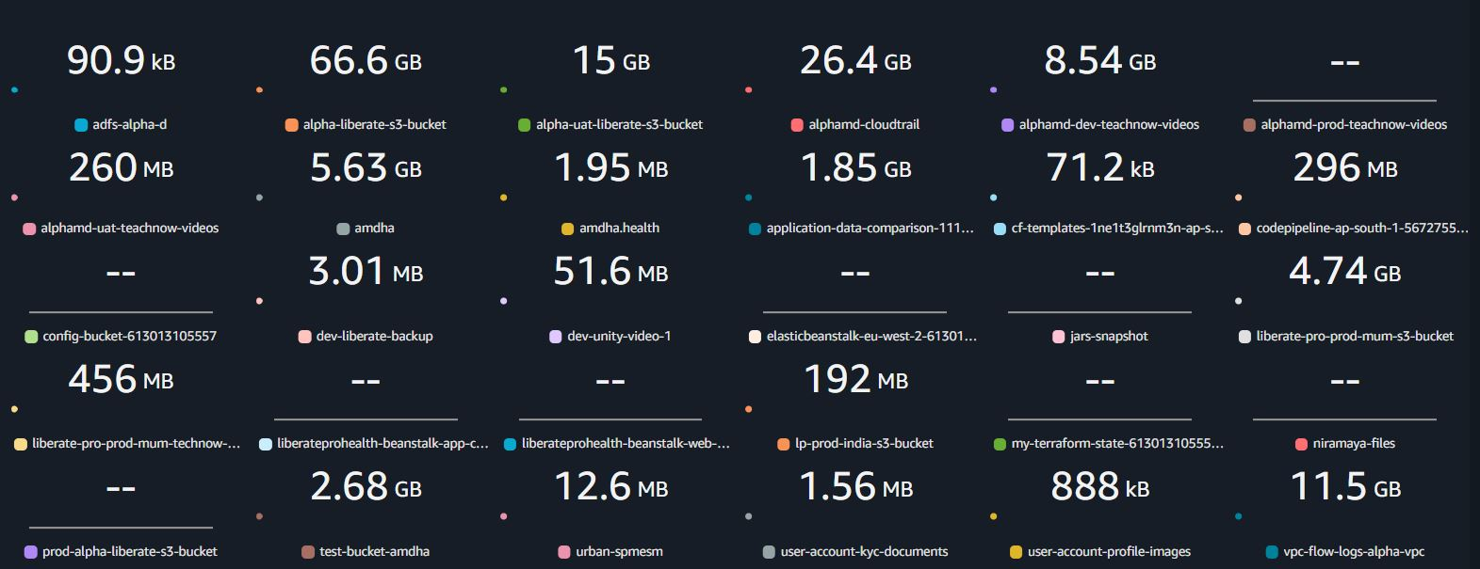
- Bucket size bytes for S3 (London Region):
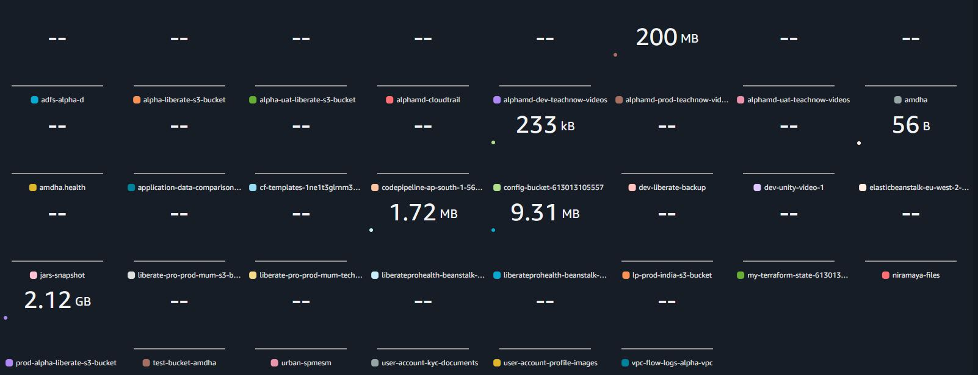
- Freeable Memory of RDS (Mumbai Region):
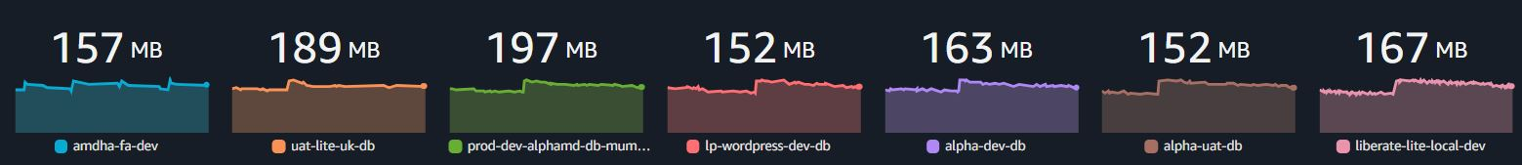
- Freeable Memory of RDS (London Region):
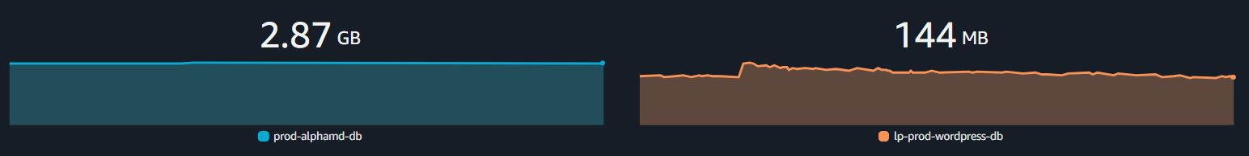
- Free Storage Space of RDS (Mumbai Region):
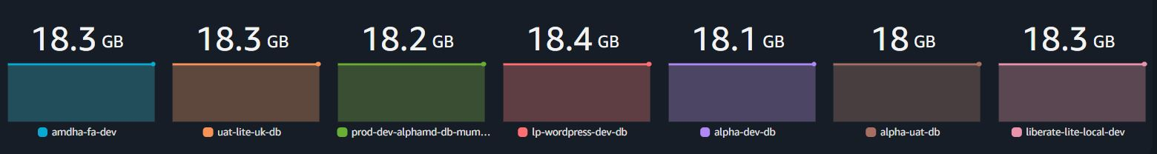
- Free Storage Space of RDS (London Region):

- RDS Read IOPS (Mumbai region):
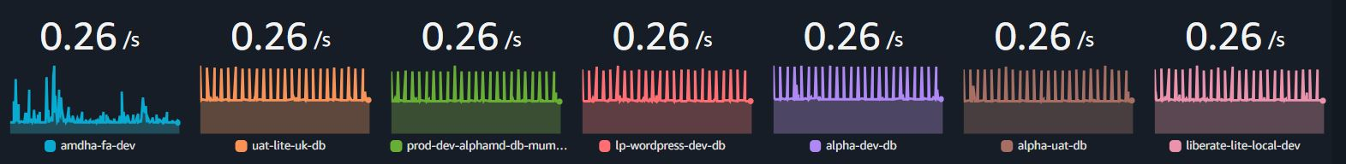
- RDS Write IOPS (Mumbai region):
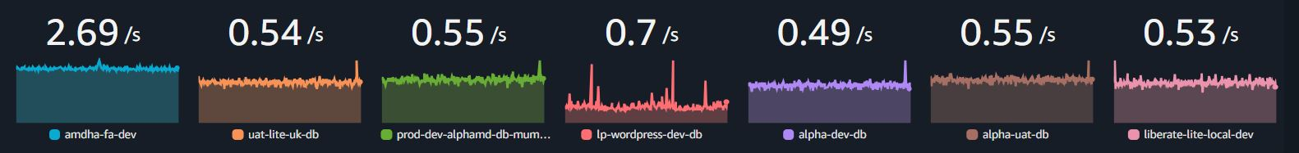
- RDS Read IOPS (London region):
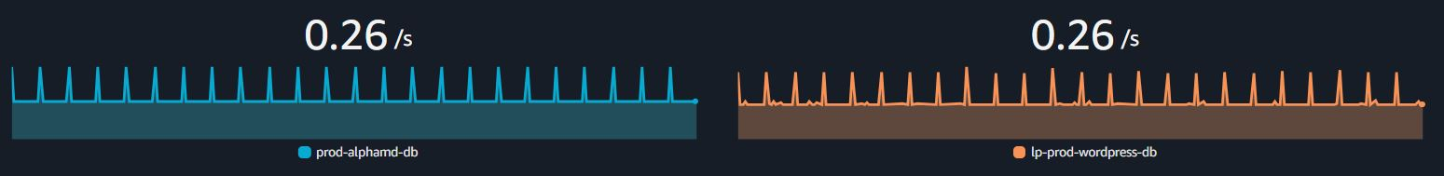
- RDS Write IOPS (London region):
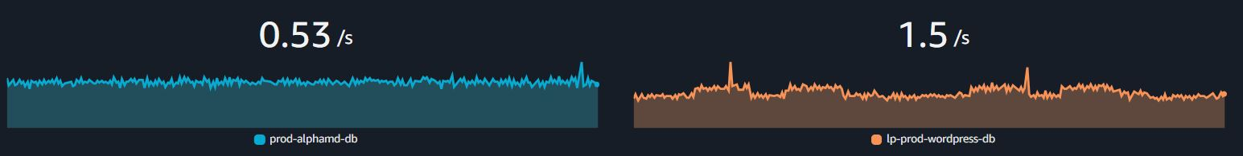
- Estimated Bills (3rd November 2025):
